Goal: Destroy your opponent 's tank before they destroy you.

To destroy opponent's tank, you must shoot its center.

The player who first reach 10 points win,

2 Players:

Single Player: Use ↑↓←→ to move

Press L to shoot bullets

3 Players:

3rd player uses Mouse to move

Press Mouse to shoot bullets

Player1:

Use WSAD to move

Press Space to shoot bullets

Player2:

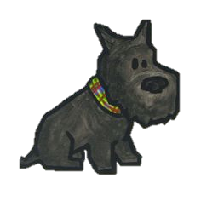 Use ↑↓←→ move

Press L to shoot bullets

Press R to restart the game, Press ESC to quite to main menu

Try to kill your opponent with as few bullets as possible